**Country Springs PFA**

**October 8th 2024 Meeting**

**Agenda**

**President – Rebecca Ahn**

* Ideas for additional fundraising initiatives:
* Get Air , Pump It Up, Party Kingdom
* See's Candies
* Holiday Shop
* Fund Photo
* Art to Remember
* Parents' Night Out
* Tax/ IRS issue still not resolved. Regina is in contact with an agent who was recommended by Robert, our CPA.
* Per Regina : Past filings and checks were delivered to the state attorney general's office on Monday, 09/23. At this point, less than 2 weeks later, none of the checks have cleared and the status from 2013 thru 2019 remain as incomplete or not submitted on the CA DOJ site."

**Principal – Mrs. Hyland**

**Assistant Principal – Mrs. Davies**

**1st VP - Jenn Holtkamp**

* Red Ribbon Week is October 21-25
* The national theme is “Life is a Movie, Film Drug Free
* Daily dress up days have been posted on school social media
* Red silicone bracelets will be given to all students and popsicles at the end of the week
* Assembly by the CH police is only offered to 6th graders this year. They modified their assemblies for RRW and only offer to older students now
* Coloring pages for door posters were distributed to each class.
  + Teachers will distribute and give to the room parents to make the poster
  + Room parents will receive an email detailing the door posters they should make and hang for this week

**2nd VP - Jenn Grevenstrale**

* Recap of fall fundraiser

**Auditor - Joanna Chen**

* Concession Stand help Google sign up sheet avail
* Started selling $10 prepaid concession stand cards; order form is in the office.
* Also, in quick 20 minutes our September concession sale is $237.
* Additional help needed for upcoming dates
* Need 3 people to help with Our October concession on 10/16 afterschool
* Need 3 people to help with 5th grade performance on 10/23.

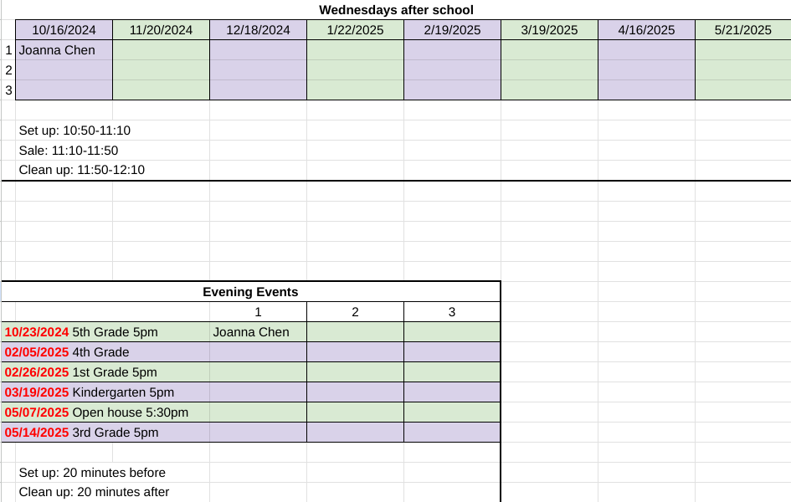

**Hospitality - Lauren Ramos, Kimberly Quintanilla and Lady Ennis**

* Discuss the date for the Staff Appreciation luncheon
* Possibly scheduled for the same day as open house; need to discuss moving it to another Wednesday.

**Scholastic Book Fair – Cyndy Chowtham, Andrew Castillo**

* Book Fair wrap up info

**Room Parent Coordinators – Hana Chen, Juni Lau, Silvia Rivas**

* Red Ribbon Week email reminder is going out
* Literature day email reminder was sent out to room parents
* Need more volunteers for 30th Anniversary game booth: social media, class dojo/remind, paper ad with QR code in front of office, recruit alumni to help